Make Up Emission Spectrum Lab

1. Using the internet find the emission spectra for the following atoms:

Helium, Argon, Mercury, Hydrogen and Neon.

2. Draw the spectrum each produces on the answer document with the wavelength markings.

3. Identify the unknown below:

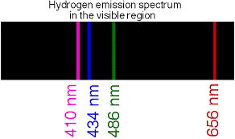

4. Answer all questions in complete sentences.